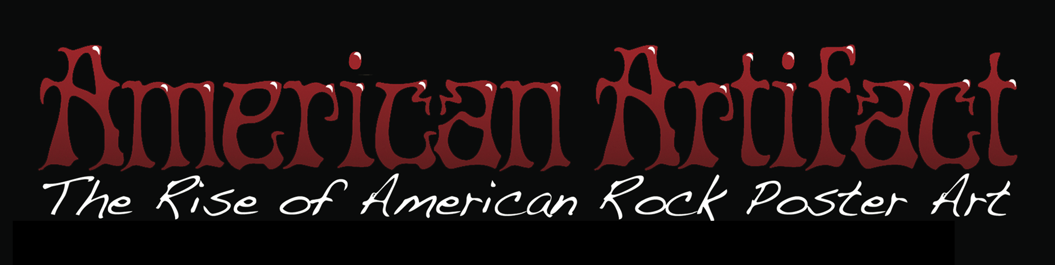

A Freakfilms, Inc. Production
Produced and Directed by: Merle Becker
TRT: 90min.

Bookings / Press Contact:
Merle Becker 646.325.6708
americanartifact@freakfilms.com

Movie website:
www.AmericanArtifactMovie.com

Downloadable production stills, logos, and other material available at:
www.Freakfilms.com/aa/press.html

For a private link to an online screener of the film in its entirety, please contact above.

PRESS KIT CONTENTS:
Short Synopsis
Long Synopsis
Director’s Statement
Director’s Bio

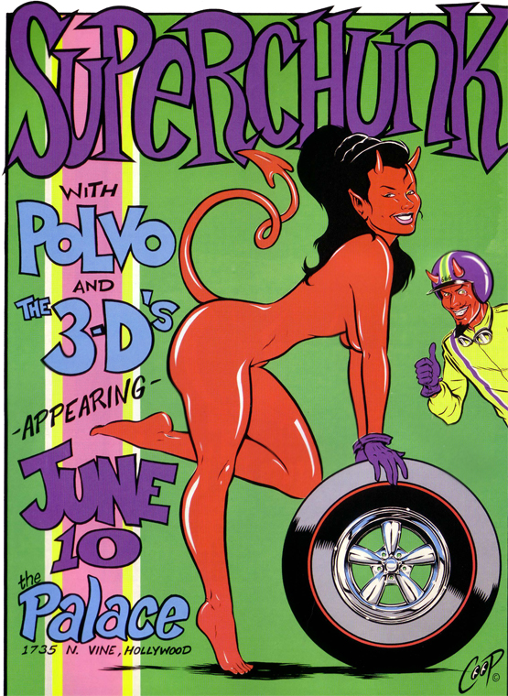
SHORT SYNOPSIS:

American Artifact chronicles the rise of American rock poster art since its birth in the '60s.

Director Merle Becker crosses the country interviewing rock poster artists from the different eras to discover that America is currently in the midst of a 21st century "rock poster art movement", where thousands of artists around the country are doing silk screened rock poster art inspired by their local scene, the music of our time, and the spirit of our era.

The film features interviews with renown artists including Stanley Mouse, Victor Moscoso, Frank Kozik, Art Chantry,
EMEK, Tara McPherson, Derek Hess, COOP, Jay Ryan, and more, as well as fans, collectors, and musicians.

LONG SYNOPSIS:

American Artifact chronicles the rise of American rock poster art since its birth in the '60s.

Director Merle Becker crosses the country interviewing rock poster artists from the different eras to discover that America is currently in the midst of a 21st century "rock poster art movement", where thousands of artists around the country are doing silk screened rock poster art inspired by their local scene, the music of our time, and the spirit of our era.

Shattering the stigma of so-called “Lowbrow Art”, this film celebrates rock poster artists and their work as important footprints left behind by cultural change, and a looking glass through which future generations can see the era we live in presently, the era of Rock and Roll.

“American Artifact” also contains interviews with musicians, fans, and collectors, including members of of Phish, the Dead Kennedys, The Avengers, and The Engligh Beat. The soundtrack features songs by the Butthole Surfers, The Slackers, The Avengers, Andrew Bird, and more.

DIRECTOR’S STATEMENT:

“I’ve always been obsessed with rock, and rock imagery.  When I was looking for a subject for my next film. I was in a bookstore, and I came across “The Art of Modern Rock” – A huge, coffee table book of modern day rock posters – It was like I had just stumbled upon a new rock art form. Rock imagery to me, up to this point was largely music videos and album covers – Both of which I loved. But, this was like a whole new addiction!  So,I got my idea for my next film. My objective was to not only give the viewer an opportunity to meet some of these artists and see some of their mind-blowing art, but to also tie it into the hisory of American culture, which of course, it’s so closely releated to.  At one point, I tried unsuccessfully to get funding for the movie, and after months of pavement-pounding, decided to quit my cushy corporate television job, and do it on my own. But, that’s the story of every artist in the film - Doing it for the love of the art, and not waiting forever for some big corporation to come along and give you wads of cash to tell your story. | 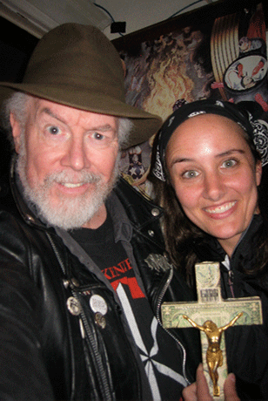  Director Merle Becker and poster artist, Winston Smith

 | DIRECTOR’S BIO:  Producer / Director Merle Becker is a 15+ year veteran of film and television programming. Credits include "CBS Tony Awards", "Beavis & Butt-Head", Comedy Central's "Tough Crowd With Colin Quinn", and MTV's "Total Request Live". She has worked on several feature films, including "Rising Low" (with Warren Haynes and Phil Lesh).

